Basic Differentiation Rules:

|  |  |  |
| --- | --- | --- |
|  |  |  |
|  |  |  |
|  |  |  |
|  |  |  |
|  |  |  |
|  |  | 18. $\frac{d}{dx}\left[\csc{u}\right]=(csc{u}\cot{u})(u')$ |
| 19. $\frac{d}{dx}[\arcsin{u]=\frac{u^{'}}{\sqrt{1-u^{2}}}}$ | 20. $\frac{d}{dx}[\arccos{u]=\frac{-u^{'}}{\sqrt{1-u^{2}}}}$ | 21. $\frac{d}{dx}\left[\arctan{u}\right]=\frac{u'}{1+u^{2}}$ |
| 22. $\frac{d}{dx}\left[\operatorname{arccot}{u}\right]=\frac{-u'}{1+u^{2}}$ | 23. | 24. |

**EXAMPLE 3:**

Tabular Data!

|  |  |  |
| --- | --- | --- |
| x | 2 | 6 |
| $$f(x)$$ | 3 | 5 |
| $$f'(x)$$ | -1 | 0 |
| $$g(x)$$ | 2 | 1 |
| $$g'(x)$$ | 6 | 8 |

1. Find the derivative of $f\left(x\right)⋅g(x) at x=2$

Using formula 3:

$\frac{d}{dx}\left[f\left(x\right)⋅g\left(x\right)\right]=f\left(x\right)g^{'}\left(x\right)+g\left(x\right)f^{'}\left(x\right)$

Then plug in x and simplify

$→f\left(2\right)g^{'}\left(2\right)+g\left(2\right)f^{'}\left(2\right)$

$→\left(3\right)\left(6\right)+\left(2\right)\left(-1\right)$

$→16$

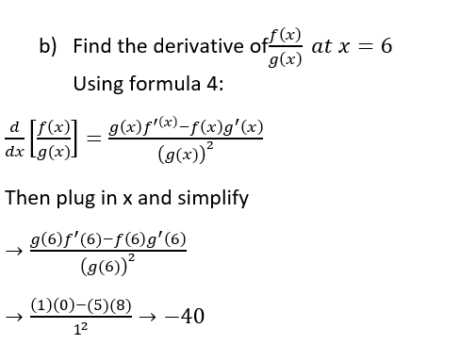

## Implicit Differentiation

Functions expressed in terms of another variable are *explicit*. These are simpler equations like $y=x^{5}-20x^{2}+3$, where y can is isolated. Sometimes functions may be given in *implicit* form like $y+20x^{2}=x^{5}+3$, where $y=x^{5}-20x^{2}+3$ is *implied.* Sometimes however, y cannot be isolated and must remain in *implicit* form, such as $x^{2}+y^{2}=1$. In this case, *implicit differentiation* can be used to differentiate the equation.

Steps for implicit differentiation:

|  |  |
| --- | --- |
| Step 1 | Differentiate both sides with respect to x |
| Step 2 | Isolate all terms involving $\frac{dy}{dx}$ to one side |
| Step 3 | Factor out $\frac{dy}{dx}$ |
| Step 4 | Isolate $\frac{dy}{dx}$ by dividing out the inner terms |
| Step 5 | If y could be isolated originally, substitute it into the current equation |

**EXAMPLE 4:**

Find $\frac{dy}{dx}$ of $xy^{2}+5x-y=y^{3}-x^{2}-5$

Step 1: Differentiate both sides with respect to x $$\left[\left(x\right)\left(2y\frac{dy}{dx}\right)+\left(y^{2}\right)\left(1\right)\right]+5-\frac{dy}{dx}=3y^{2}\frac{dy}{dx}-2x-0$$

Step 2: Group all $\frac{dy}{dx}$ terms to one side $$2xy\frac{dy}{dx}-\frac{dy}{dx}-3y^{2}\frac{dy}{dx}={-y}^{2}-5-2x$$

Step 3: Pull out $\frac{dy}{dx}$ $$\frac{dy}{dx}\left[2xy-1-3y^{2}\right]=-y^{2}-5-2x$$

Step 4: Isolate $\frac{dy}{dx}$ $$\frac{dy}{dx}=\frac{-y^{2}-5-2x}{2xy-1-3y^{2}}$$

Step 5: We can’t substitute y here because it was not isolatable in the original equation